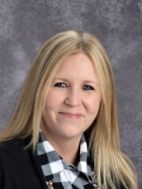

Dear Heritage Elementary School Learning Community,  
  
It is a privilege and an honor to serve as the Principal of Heritage Elementary School. I would like to take this opportunity to share some of my background information with you.

Personally, I am a proud wife and mother. We have two daughters. I enjoy all of the activities in which they are involved and embrace the time we share together as I watch them learn and grow.

Professionally, I began my career as a teacher in CPS and then later Schaumburg School District 54. I’ve had the opportunity to teach several grade levels from second grade to high school. I’ve served as an Instructional Coach and as an Assistant Principal. School District U-46 provided me honor to serve the Heritage community for the past nine years.

I value my educational experiences and strive to be a model of life-long learning. I’m a proud graduate of DePaul and Eastern Illinois University.   
  
My goal as the instructional leader of Heritage Elementary School is to work collaboratively with all elements of our Heritage Community to foster a safe and effective learning environment. While engaging students through content, instruction, and technology, we will strive to support each student’s social, emotional, and academic growth as well as the District’s mission to ensure all students are college or career ready upon graduation.

As Principal of Heritage Elementary School, I look forward to learning more about you and your student in 2019-2020, as we work in partnership to support your child’s success. Building relationships and establishing effective lines of communication is so important to me.

Please feel free to contact me at anytime.

Warm Regards,

Catherine Fletcher  
[catherinefletcher@u-46.org](mailto:catherinefletcher@u-46.org)